Tutorial 8: More Robot Framework Exercises
In this tutorial, you will explore more features within Robot Framework.
A: Test Templates
In this exercise, you will use templates to setup test cases with different inputs.
Test templates convert normal keyword-driven test cases into data-driven tests. Whereas the body of a keyword-driven test case is constructed from keywords and their possible arguments, test cases with template contain only the arguments for the template keyword. Instead of repeating the same keyword multiple times per test and/or with all tests in a file, it is possible to use it only per test or just once per file.
You can read more about test templates at https://robotframework.org/robotframework/latest/RobotFrameworkUserGuide.html#test-templates
Tasks:
- You are to use the same login registration system shown in Tutorial 7 to setup 3 test suites (3 robot files) for the login page:
  - Valid login – should contain a single test case for valid username and valid password
  - Invalid login – should contain 3 test cases of:
    - Invalid username and valid password
    - Valid username and invalid password
    - Invalid username and invalid password
  - Empty login – should contain 3 test cases of:
    - Empty username and valid password
    - Valid username and empty password
    - Empty username and empty password
  - Setup necessary keywords and variables so that all three files utilise the same resource.
  - If you are not sure how to start, go to https://www.planittesting.com/au/insights/2017/robot-framework for guidance.
  - You can also view a short demo on robot framework for this task on Learnline > Week 8 > Tasks. There is no sound for this recording, this is just to show how automation can be done using Robot Framework.

- The above task has six separate tests for invalid and empty login combination. Your task now is to have only one test with all the combinations and still uses the template feature within Robot framework. It will look like this:
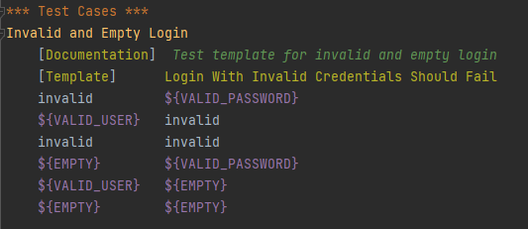
  - It should also utilise the same resource setup in task 1.
B. Automation on Blazedemo
In this task, you will be using Robot Framework to perform automatic testing for this website: https://blazedemo.com/index.php
Task:
- You should setup 3 test cases:
    - Searching for flights – selecting departure and destination city then search for available flights
    - Choosing flights – making sure there are flights available and choosing a particular option
    - Purchase tickets – enter personal details and purchase ticket. A screenshot of the invoice should be captured.
- Setup necessary keywords and variables for the 3 test cases above.
- If you are not sure how to start, go to https://www.blazemeter.com/blog/robot-framework for guidance.
- You can also view a short demo on robot framework for this task on Learnline > Week 8 > Tasks. There is no sound for this recording, this is just to show how automation can be done using Robot Framework. The program was run twice – the first time at a normal speed and the second time at a very fast speed.

